PRACTICAL NO 1

AIM: Study of Packet Tracer Software Interface

THEORY:
Packet Tracer is a powerful network simulator that can be utilized in training for Network certifications by allowing students to create networks with an almost unlimited number of devices and to experience troubleshooting without having to buy real Cisco routers or switches. The tool is created by Cisco Systems. The purpose of Packet Tracer is to offer students a tool to learn the principles of networking as well as develop Cisco technology specific skills. However, it is not be used as a replacement for Routers or Switches.
1) Network Design
Packet Tracer is used by some network administrators to design networks. Creating topology guides with a tool like packet tracer is preferable to using pen and paper because you can add and remove new features without having to scribbe anything out and start from scratch!
2) Testing Out Changes in a Safe Environment
Cisco Packet Tracer is also used by professional network administrators for testing network changes. Before changing a network the user can try out new topology changes to see if everything works correctly. If there aren’t any hiccups then the changes can be deployed in a live network.
This initial interface contains ten components. If you are unsure of what a particular interface item does, move your mouse over the item and a help balloon will explain the item.
1 | Menu Bar | This bar provides the File, Edit, Options, View, Tools, Extensions, and Help menus. You will find basic commands such as Open, Save, Save as Pkz, Print, and Preferences in these menus. You will also be able to access the Activity Wizard from the Extensions menu.
2 | Main Tool Bar | This bar provides shortcut icons to the File and Edit menu commands. This bar also provides buttons for Copy, Paste, Undo, Redo, Zoom, the Drawing Palette, and the Custom Devices Dialog. On the right, you will also find the Network Information button, which you can use to enter a description for the current network (or any text you wish to include).
3 | Common Tools Bar | This bar provides access to these commonly used workspace tools: Select, Move Layout, Place Note, Delete, Inspect, Resize Shape, Add Simple PDU, and Add Complex PDU. See “Workspace Basics” for more information.
4 | Logical/Physical Workspace and Navigation Bar | You can toggle between the Physical Workspace and the Logical Workspace with the tabs on this bar. In Logical Workspace, this bar also allows you to go back to a previous level in a cluster, create a New Cluster, Move Object, Set Tiled Background, and Viewport. In Physical Workspace, this bar allows you to navigate through physical locations, create a New City, create a New Building, create a New Closet, Move Object, apply a Grid to the background, Set Background, and go to the Working Closet.
5 | Workspace | This area is where you will create your network, watch simulations, and view many kinds of information and statistics.
6 | Realtime/Simulation Bar | You can toggle between Realtime Mode and Simulation Mode with the tabs on this bar. This bar also provides buttons to Power Cycle Devices and Fast Forward Time as well as the Play Control buttons and the Event List toggle button in Simulation Mode. Also, it contains a clock that displays the relative Time in Realtime Mode and Simulation Mode.
7 | Network Component Box | This box is where you choose devices and connections to put into the workspace. It contains the Device-Type Selection Box and the Device-Specific Selection Box.
8 | Device-Type Selection Box | This box contains the type of devices and connections available in Packet Tracer. The Device-Specific Selection Box will change depending on which type of device you choose.
9 | Device-Specific Selection Box | This box is where you choose specifically which devices you want to put in your network and which connections to make.
10 | User Created Packet Window* | This window manages the packets you put in the network during simulation scenarios. See the “Simulation Mode” section for more details.

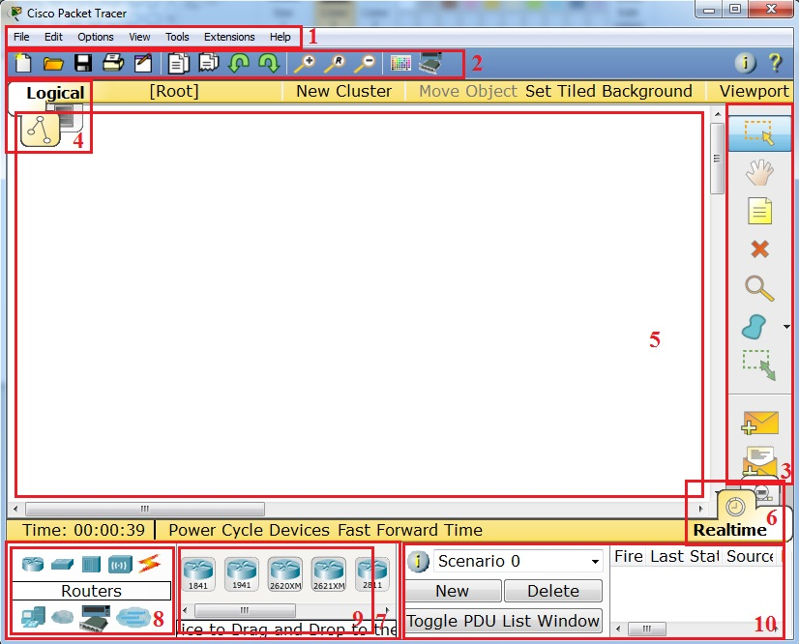
AIM: Basic Configuration on console by setting password –
(a) Basic Router configuration with password

THEORY:
Cisco IOS supports various command modes, among those followings are the main command modes.
Mode | Prompt | Command to enter | Command to exit
User EXEC | Router > | Default mode after booting. Login with password, if configured. | Use exit command
Privileged EXEC | Router # | Use enable command from user exec mode | Use exit command
Global Configuration | Router(config)# | Use configure terminal command from privileged exec mode | Use exit command
Interface Configuration | Router(config-if)# | Use interface type number command from global configuration mode | Use exit command to  return in global  configuration mode
Sub-Interface Configuration | Router(config-subif) | Use interface type sub interface number command from global configuration mode or interface configure mode | Use exit to return  previous mode.  Use end command  to return in  privileged exec mode.
Setup | Parameter[Parameter value]: | Router will automatically insert in this mode if running configuration is not present | Press CTRL+C to  abort. Type yes to  save configuration,  or no to exit without  saving when asked in  the end of setup.
ROMMON | ROMMON > | Enter reload command from privileged exec mode. Press CTRL + C key combination during the first 60 seconds of booting process | Use exit command.
We can configure any desired name on router. hostname command will change the name of router. For example following command will assign LAB1 name to the router.
Router is a critical device of network. It supports multiple lines for connection. We need to secure each line [port].
CODE:
Router>en
Router#conf t
Enter configuration commands, one per line. End with CNTL/Z.
Router(config)#line console 0
Router(config-line)#password user@48
Router(config-line)#login
Router(config-line)#exit
Router(config)#exit
Router#
%SYS-5-CONFIG_I: Configured from console by console
wr
Building configuration...
[OK]
Router#reload

OUTPUT:

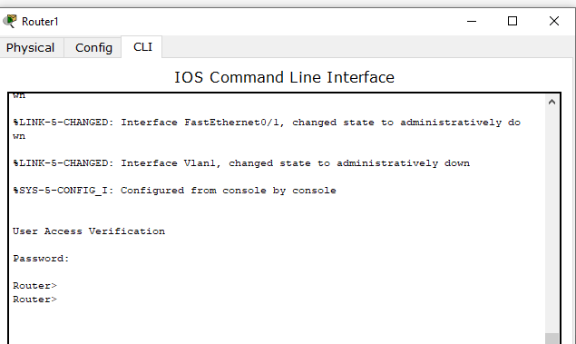
AIM: Basic Configuration on console by setting password –
(b) Configure Switch with MOTD

THEORY:
A banner is a message presented to a user who is using the Cisco switch. The type of banner you configured for use determines when this message is shown. You can configure three main types of banners on your Cisco switch, as shown here:
ADVERTISING
- Message of the Day (MOTD): This type of logon message has been around for a long time on Unix and mainframe systems. The idea of the message is to display a temporary notice to users, such as issues with system availability.
However, because the message displays when a user connects to the device prior to login, most network administrators are now using it to display legal notices regarding access to the switch, such as unauthorized access to this device is prohibited and violators will be prosecuted to the full extent of the law and other such cheery endearments.
- Login: This banner is displayed before login to the system, but after the MOTD banner is displayed. Typically, this banner is used to display a permanent message to the users.
- Exec: This banner displays after the login is complete when the connecting user enters User EXEC mode. Whereas all users who attempt to connect to the switch see the other banners, only users who successfully log on to the switch see this banner, which can be used to post reminders to your network administrators.

CODE:

To display MOTD(Message of the Day)
Command is : banner motd #Your message to display#Click exit till Router#.
When you try to enable router it will display your message of the day(MOTD) as shown
below.

OUTPUT:

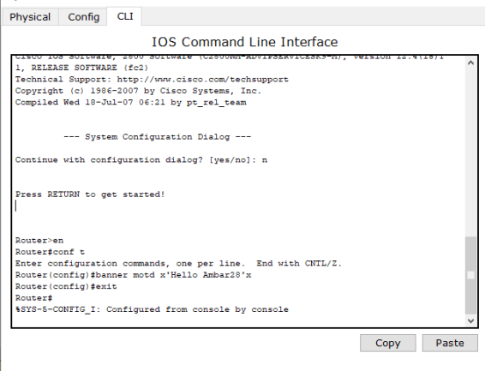
AIM:
1.3-CONNECT MULTIPLE PC’S WITH HUB AND SHOW ARP CABLE OF PC

THEORY:
• What is ARP? What is it used for?
The Address Resolution Protocol (ARP) feature performs a required function in IP routing. ARP finds the hardware address, also known as Media Access Control (MAC) address, of a host from its known IP address. ARP maintains a cache (table) in which MAC addresses are mapped to IP addresses. ARP is part of all Cisco systems that run IP.

The Address Resolution Protocol (ARP) was developed to enable communications on an internetwork and is defined by RFC 826. Layer 3 devices need ARP to map IP network addresses to MAC hardware addresses so that IP packets can be sent across networks. Before a device sends a datagram to another device, it looks in its ARP cache to see if there is a MAC address and corresponding IP address for the destination device. If there is no entry, the source device sends a broadcast message to every device on the network. Each device compares the IP address to its own. Only the device with the matching IP address replies to the sending device with a packet containing the MAC address for the device (except in the case of "proxy ARP"). The source device adds the destination device MAC address to its ARP table for future reference, creates a data-link header and trailer that encapsulates the packet, and proceeds to transfer the data.

• What is a hub?

When referring to a network, a hub is the most basic networking device that connects multiple computers or other network devices together. Unlike a
network switch or router, a network hub has no routing tables or intelligence on where to send information and broadcasts all network data across each connection.
Most hubs can detect basic network errors such as collisions, but having all
information broadcast to multiple ports can be a security risk and cause bottlenecks.
In the past, network hubs were popular because they were cheaper than a switch or router. Today, switches do not cost much more than a hub and are a much better solution for any network.

• Types of hub

Passive Hub: This type of hub does not amplify or boost the signal. It does not manipulate or view the traffic that crosses it. Passive hub does not require electrical power to work.

Active Hub: It amplifies the incoming signal before passing it to the other ports. It requires AC power to do the task.

Intelligent Hub: They are also called as smart hubs. It functions as active hub and also include diagnostic capabilities. Intelligent hubs include microprocessor chip and are very useful in troubleshooting conditions of the network.

Step 1: Connect 4 PC’s to a hub

Step 2: To configure ip-address for each PC click on PC then click on Desktop tab Then you will get following window type address, subnet mask and gateway.
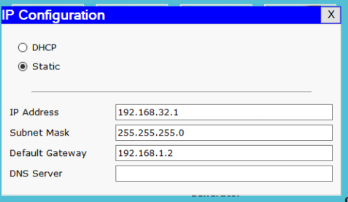
Step 3:
Click on any PC go to Desktop.
Click on command prompt.and ping to each PC using command.
Syntax : ping ip-address.
After pinging each PC in network find ARP table.
For ARP table command is:
Syntax : arp -a

